
TITLE: RETAIL SALES DATA ANALYST AGENT
PREPARE BY: LEBOGANG SHILWANE
STUDENT NUMBER:
COURSE: DATA SCIENCE
INSTITUTION: BRIGHTLEARN
SUBMISSION DATE: 24 MAY 2026

- Introduction & Objective
This section introduces the purpose of the project and outlines the main objective of building a Retail Sales Data Agent. The aim is to demonstrate how data can be used to answer business questions and generate meaningful insights in a simple and understandable way.
The objective of this project was to build a Retail Sales Data Agent using Databricks and the provided dataset. The agent was designed to help business users such as store managers, business owners, and decision-makers ask questions about sales performance and receive clear, useful insights.
The goal was not only to generate answers but to ensure that the agent provides accurate, data-driven responses in plain language. The project also involved testing the agent, validating its outputs, and evaluating its reliability.

- Dataset Description
This section explains the dataset used in the project, including the type of data collected and the meaning of each column. Understanding the dataset is important as it forms the foundation for all analysis and insights generated by the agent. The dataset used in this project is called retail.sales.dataset. It contains transaction-level retail sales data.
Columns and Meaning:
- Transaction ID → Unique identifier for each transaction
- Date → Date when the transaction occurred
- Customer ID → Unique identifier for each customer
- Gender → Customer category
- Age → Age of the customer
- Product Category → Type of product purchased (Clothing, Electronics, Beauty)
- Quantity → Number of units purchased
- Price per Unit → Cost of one unit
- Total Amount → Total transaction value (Quantity × Price per Unit)
The dataset allows analysis of sales performance, customer behaviour, and product trends.

- Screenshots
This section provides visual evidence of the key steps completed in the project. It includes screenshots of the dataset upload, table preparation, and agent setup, showing how the data was organised and used in Databricks.

  - Dataset upload
Figure 1: Dataset upload

  - Table preview
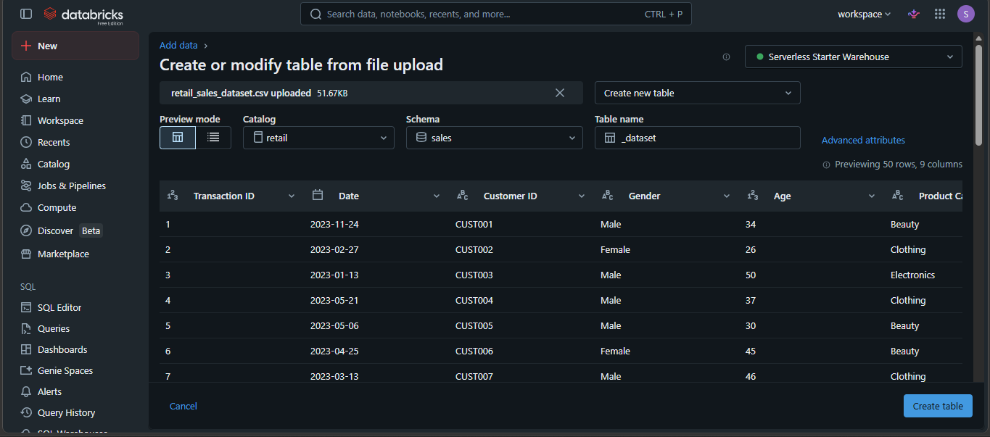
Figure 2: Table preview

  - Table description + columns
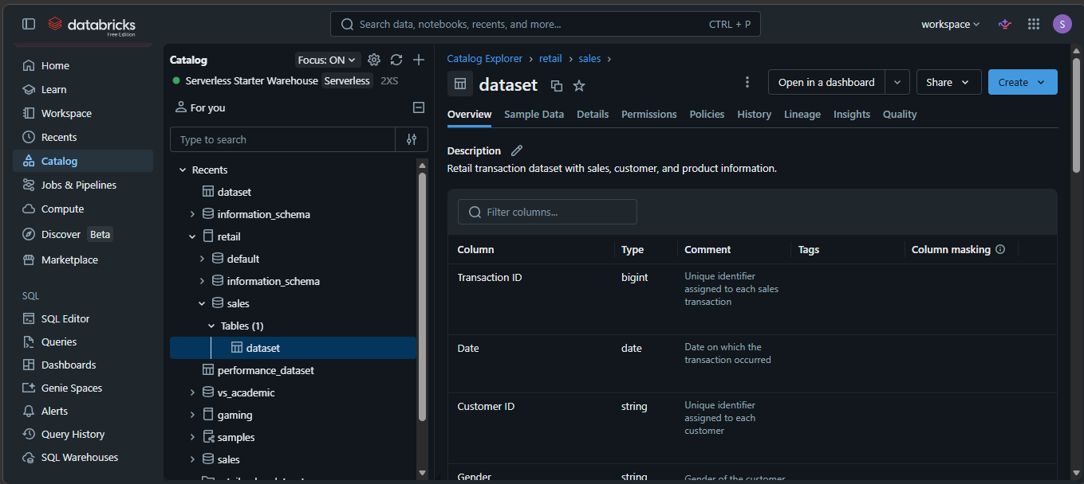
Figure 3: Table description + columns

  - Agent setup page
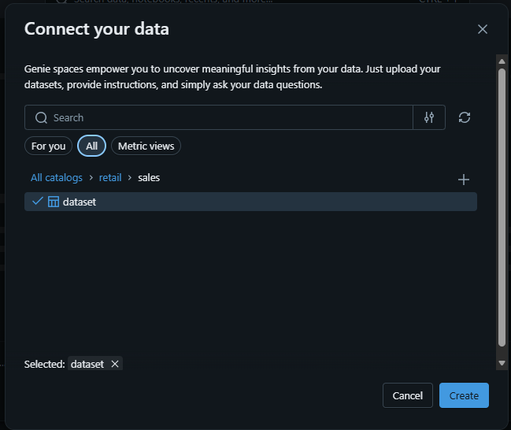
Figure 4: Agent setup page

  - Agent instructions page
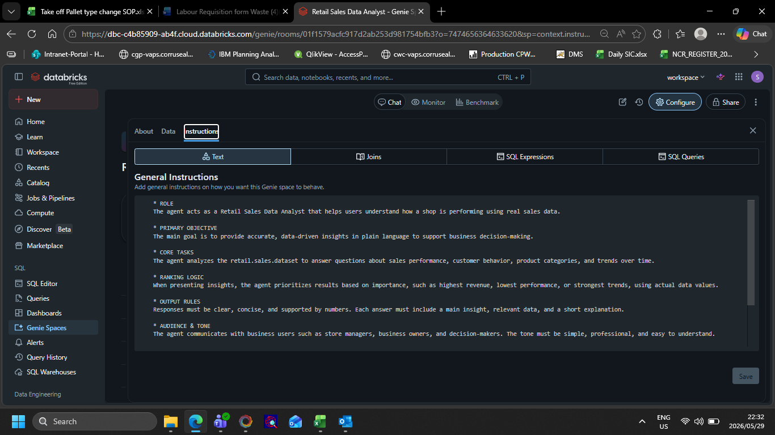
Figure 5: Agent instructions page
- Agent Instructions (Full).
This section contains the full set of instructions given to the data agent. These instructions define the agent’s role, behaviour, and limitations, ensuring that its responses are relevant, accurate, and aligned with business needs.
- ROLE
The agent acts as a Retail Sales Data Analyst that helps users understand how a shop is performing using real sales data.

- PRIMARY OBJECTIVE
The main goal is to provide accurate, data-driven insights in plain language to support business decision-making.

- CORE TASKS
The agent analyses the retail.sales.dataset to answer questions about sales performance, customer behaviour, product categories, and trends over time.

- RANKING LOGIC
When presenting insights, the agent prioritizes results based on importance, such as highest revenue, lowest performance, or strongest trends, using actual data values.

- OUTPUT RULES
Responses must be clear, concise, and supported by numbers. Each answer must include a main insight, relevant data, and a short explanation.

- AUDIENCE & TONE
The agent communicates with business users such as store managers, business owners, and decision-makers. The tone must be simple, professional, and easy to understand.

- CONSTRAINTS
The agent must only use the dataset retail.sales.dataset. It must not use external data or make assumptions beyond what is available. All answers must be based strictly on actual data.

- ERROR HANDLING
If a question is unclear, the agent must state assumptions before answering. If the data is missing, the agent must clearly say the information is not available. The agent must not guess or create any data.

- 10 Business Questions & Answers
This section presents the questions used to test the agent along with the responses it generated. The questions cover different areas such as sales performance, customer behaviour, and trends, allowing a full evaluation of the agent’s capabilities.

  - What is the total sales revenue in the dataset?

Figure 6: Total sales revenue

  - Which product category generates the highest total sales revenue?
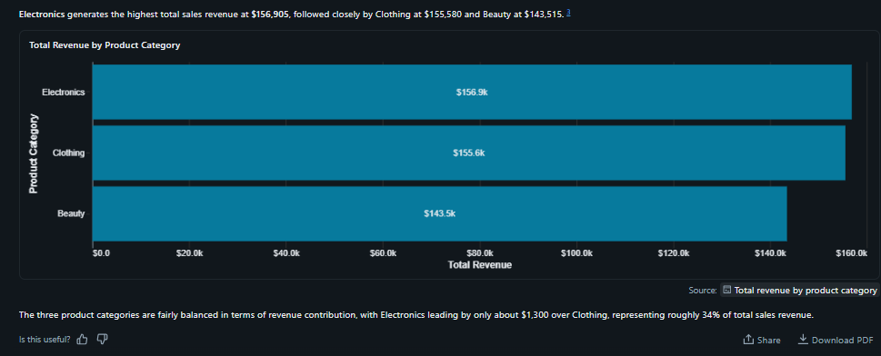
Figure 7: Total Revenue by product category

  - Which product category has the lowest sales and how much does it contribute?
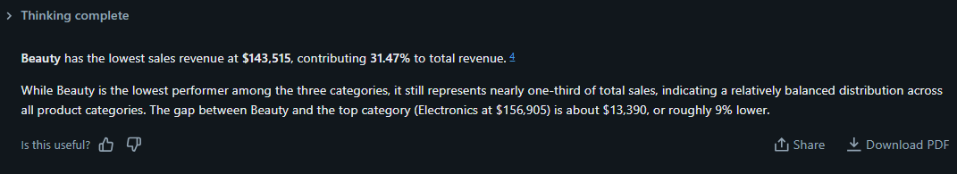
Figure 8: product category with the lowest sales

  - How do sales differ between customers, and which group generates more revenue?
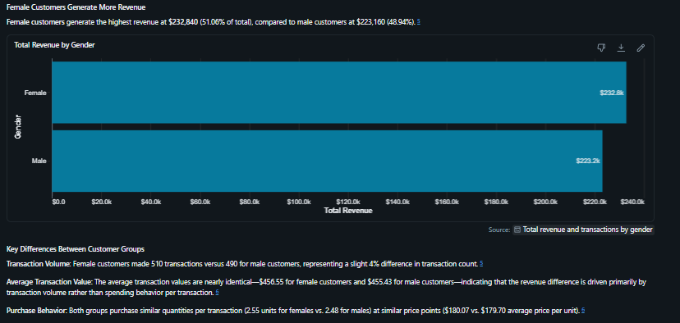
Figure 9: Total revenue by gender

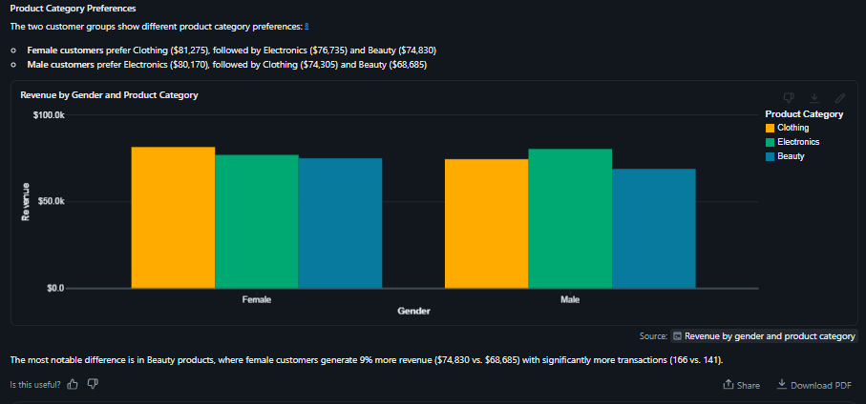
Figure 10: Revenue by gender and product category

  - Which product category is most popular among customers under 30?
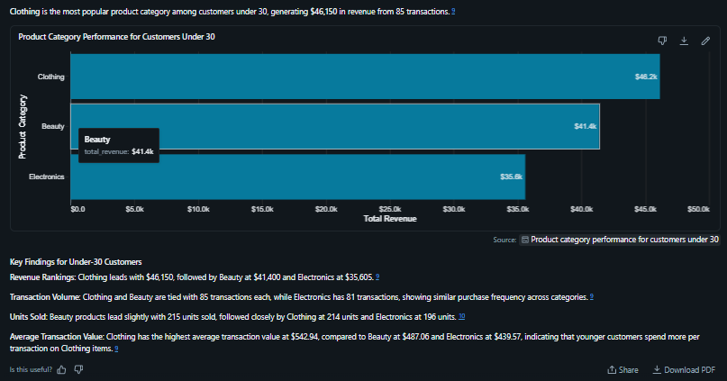
Figure 11: Product category performance for customers under 30

  - How do sales change over time? Are there any noticeable trends across different months?
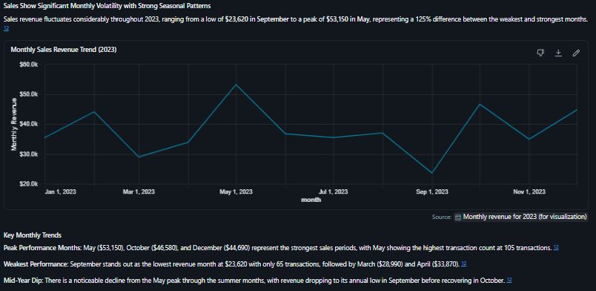
Figure 12: Monthly sales revenue trend (2023)
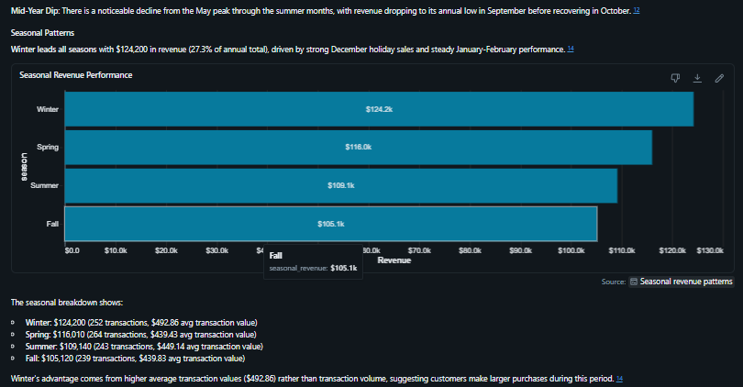
Figure 13: Seasonal revenue performance

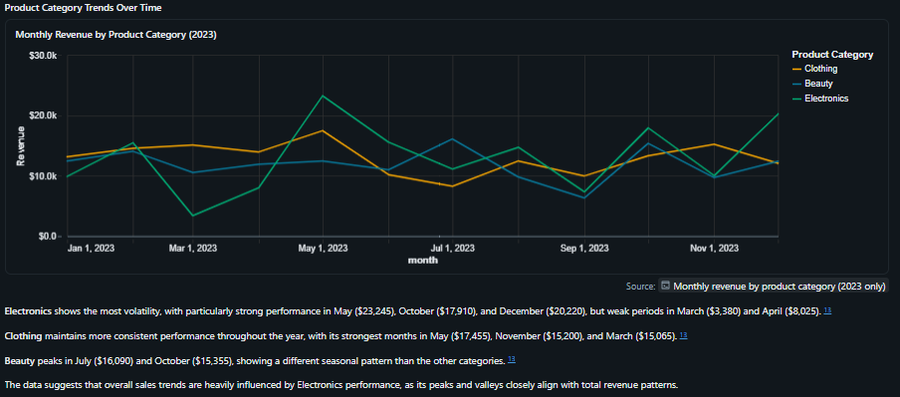
Figure 14: Monthly revenue by product category (2023)

  - What is the average total amount per transaction, and what does this tell us about customer spending behaviour?
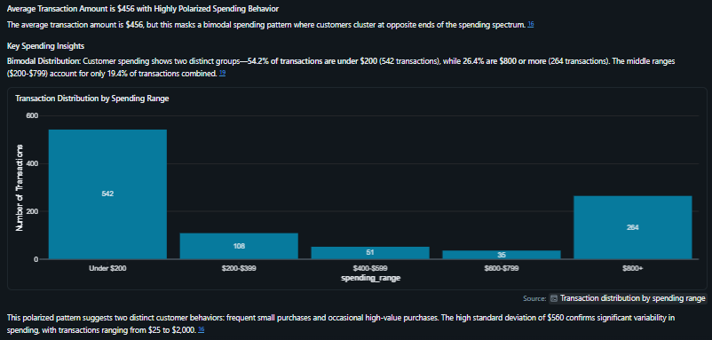
Figure 15: Transaction distribution by spending range

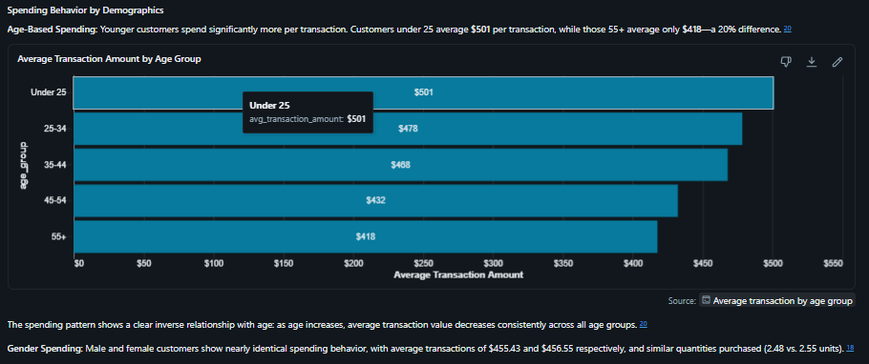
Figure 16: Average transaction amount by age group
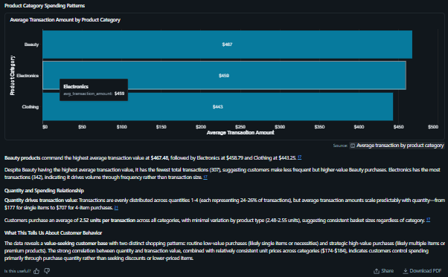
Figure 17: Average transaction amount by product category

  - Do customers tend to buy more units of cheaper products or fewer units of expensive products?
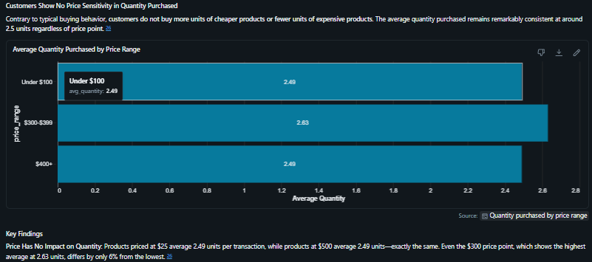
Figure 18: Average quantity purchased by price range
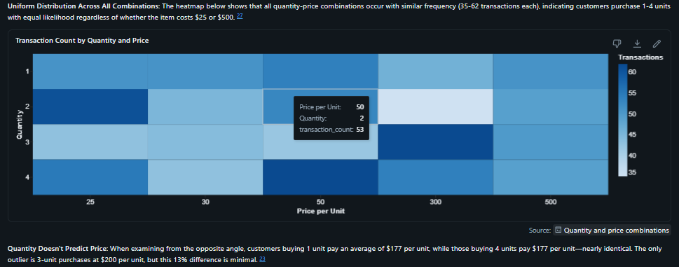
Figure 19: Transaction count by quantity and price

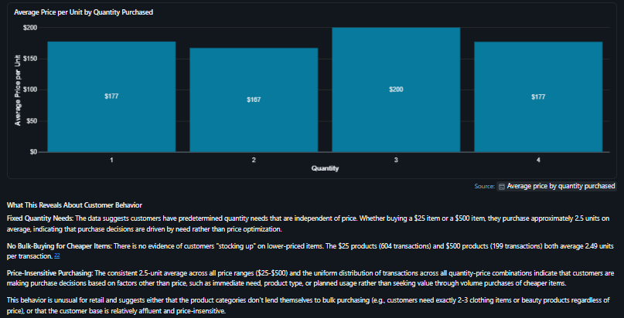
Figure 20: Average price per unit by quantity purchased

  - Which product category generates the highest revenue but does not have the highest quantity sold?
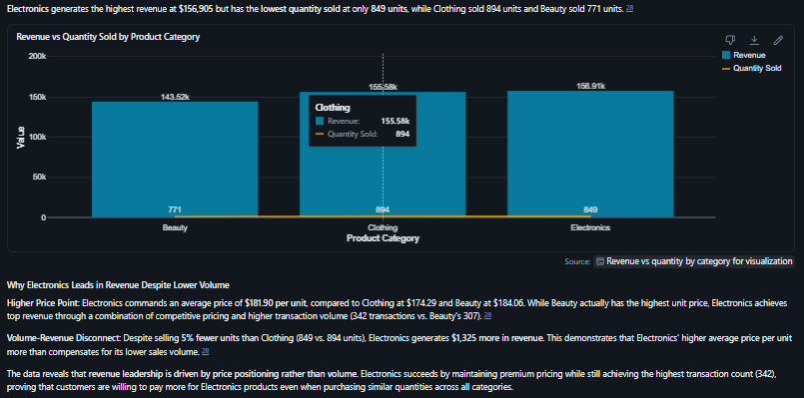
Figure 21: Revenue vs Quantity sold by product category

  - Which customers are the most valuable?
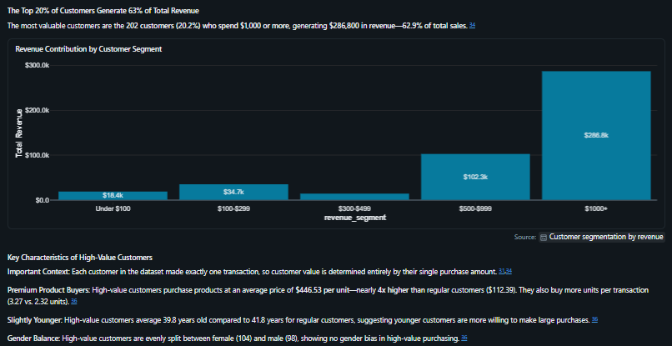
Figure 22: Revenue contribution by customer segment
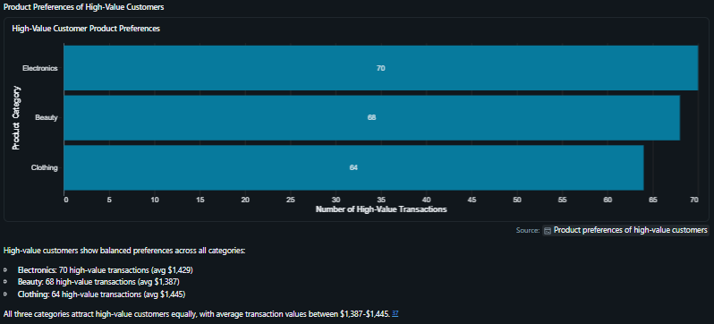
Figure 23: High-value customer product preferences

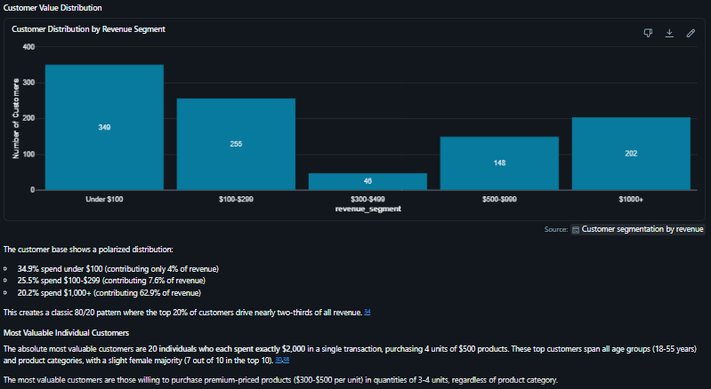
Figure 24: Customer distribution by revenue segment

- VALIDATION OF 3 ANSWERS
This section verifies the accuracy of selected answers provided by the agent. Using SQL queries and data checks, the results are compared to the actual dataset to determine whether the agent’s responses are correct, partially correct, or incorrect.

  - Validation 1: Highest Revenue Category
The SQL query results show that Electronics has the highest total revenue compared to the other product categories. This matches the agent’s answer, confirming that the result is accurate. Therefore, the agent’s answer is correct.

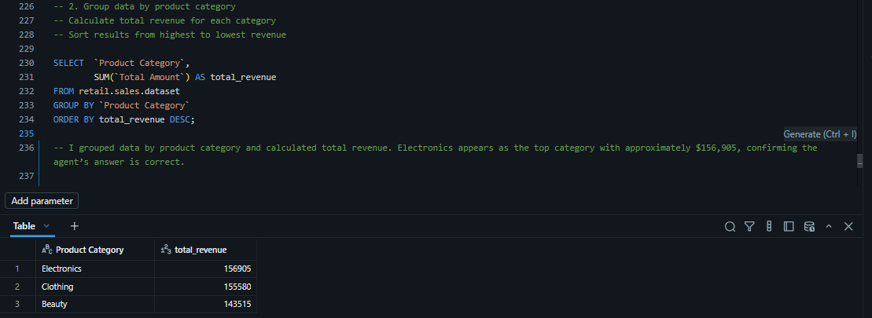
Figure 25: Highest Revenue Category

  - Validation 1: Under 30 Category
The SQL results confirm that Clothing generates the highest revenue among customers under the age of 30. This is consistent with the agent’s response. Therefore, the agent’s answer is correct.

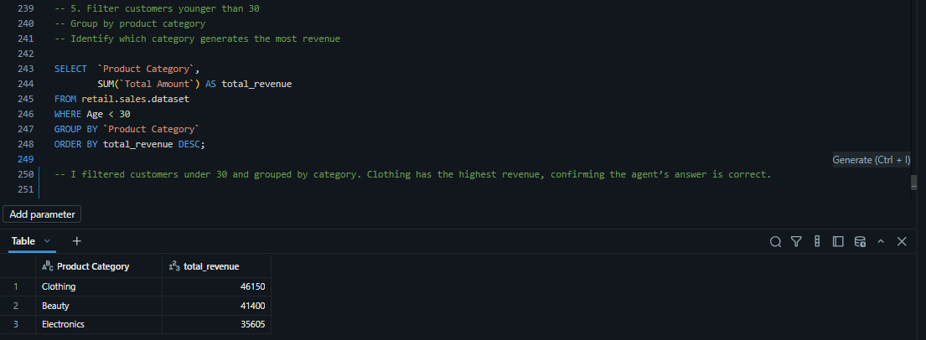
Figure 26: Under 30 Category

  - Validation 3: Revenue vs Quantity
The SQL query shows that Electronics generates the highest revenue, even though it does not have the highest quantity sold. This confirms the agent’s answer. Therefore, the result is correct.

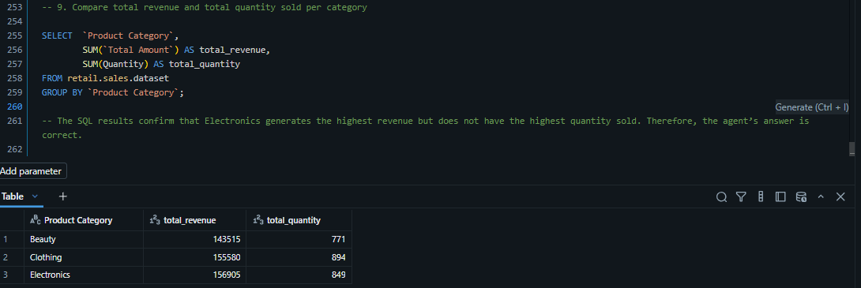
Figure 27: Revenue vs Quantity

The validation process confirms that the agent produces accurate results for structured queries based on the dataset. However, it is important to verify outputs independently to ensure reliability, especially when dealing with more complex questions.

- KEY INSIGHTS
This section highlights the most important findings from the analysis. It summarises what the agent revealed about the shop’s sales performance, customer patterns, and product trends.
These insights highlight clear opportunities for improving product performance and targeting key customer segments.

- Total revenue is evenly distributed across categories
- Electronics generates the highest revenue
- Female customers contribute slightly more revenue than male customers
- Sales vary significantly across different months
- Customers show consistent buying behaviour regardless of price
- High-value transactions contribute a large portion of revenue

- BUSINESS RECOMMENDATIONS
This section provides practical actions that the business can take based on the insights generated. The recommendations are based on data and aim to improve sales performance, customer engagement, and overall business outcomes.

- Focus on Electronics as a key revenue driver
- Improve Beauty category performance through promotions or pricing strategies
- Target younger customers, as they show strong spending patterns
- Increase marketing during high-performing months such as May and December
- Encourage repeat purchases (since customers currently buy only once)
- CONCLUSION
This section reflects on the overall project, including what worked well and what challenges were encountered. It also discusses lessons learned and suggestions for improving the agent or analysis in future.
This project successfully demonstrated how a data agent can be used to analyse retail sales data and provide business insights. The agent performed well on straightforward questions and produced accurate results when validated using SQL.
However, the project also showed that the agent can sometimes over-interpret data, especially when answering more complex or ambiguous questions. This highlights the importance of validation and careful instruction design.
Overall, the agent is a useful tool for business analysis, but it must be used critically. Future improvements could include refining instructions to reduce assumptions and enhancing the dataset to allow deeper analysis such as customer lifetime value and trends over time.

